2025 Fall Color Run — Weston, MO
Sunday, October 26, 2025
Hosted by Dollia and Jose Lemus
CCKC members, come join for our 2025 Fall Color Run to Weston, MO. We will meet at the Kansas City Monarchs parking lot in Legends and then embark on a scenic fall drive through to HWY 5, Leavenworth, KS and up to Weston, MO.
Meeting location & time: Kansas City Monarchs parking lot, 1800 Village West Pkwy, Kansas City, KS 66111 at 9:00 am. Plan on departing promptly from the Monarchs parking lot at 9:30 am.
Lunch: There are several options for lunch such as O’Malley’s Pub, Tin Kitchen and Avalon Café.
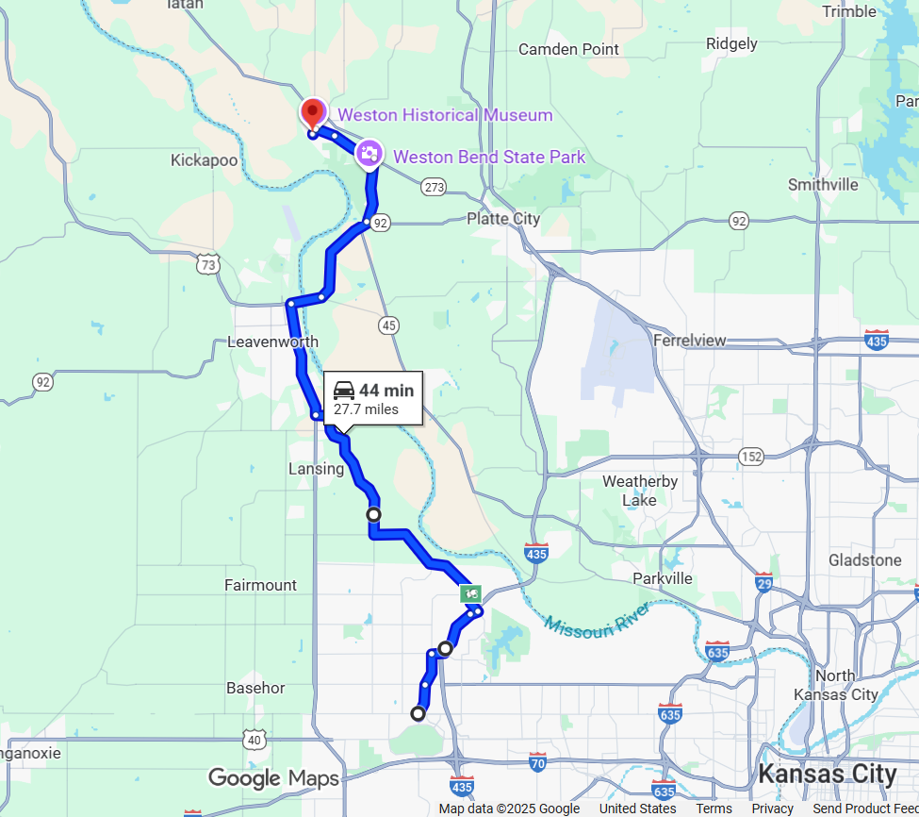
If you have any questions, you may contact me at jlemus24@hotmail.com or 706.844.7613.

